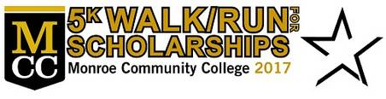

Join Team MCC Global on Saturday, October 7th for MCC’s Homecoming 5K Walk/Run for Scholarships.

All proceeds for Team MCC Global will be directed to support study abroad and international & immigrant student programs. Join our team or make a financial gift of support.

What: MCC’s Homecoming 5K Walk/Run for Scholarships
When: Saturday, October 7th
Time: 9:30 am registration, check-in, pre-race festivities begin & 11:00 am race starts
Who: Team MCC Global is a group of students, staff, faculty, family, and friends
Fee: $10 for students
Included: Race t-shirt and the chance to win a scholarship
Scholarships: A total of $5,000 is scholarships will be awarded to current MCC student 5K participants during the tailgate party after the race.
How: To register, follow this link: www.monroecc.edu/go/5K

- Click REGISTER HERE.
- Select JOIN A TEAM.
- Select SEARCH FOR A TEAM and click “Join” next to MCC GLOBAL.
- Accept the terms and conditions.
- Complete the Participation Options, and click NEXT STEP (Student Registration for $10).
- Fill in your information.
- Proceed to payment.

